Cabinet Position | Name | Picture | Very Short Job Description
Secretary of State | Hillary Clinton | 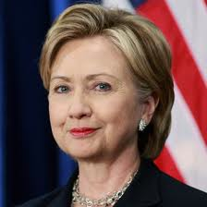 | Foreign affairs
Secretary of Treasury | Timothy Geithner | 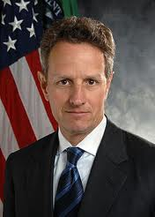 | Controls money
Secretary of Defense | Leon Panetta | 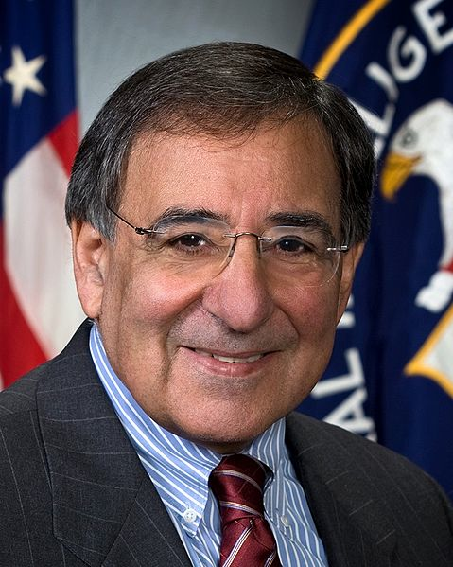 | Military
Attorney General | Eric Holder | 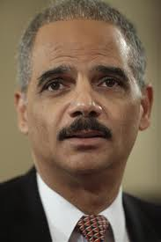 | Lawyers/ drugs
Secretary of Interior | Kenneth Salazar | 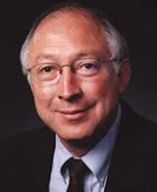 | Preserves American heritages
Secretary of Agriculture | Thomas Vilsack | 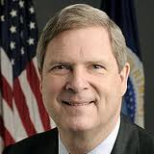 | Food, resources
Secretary of Commerce | Rebecca Blank | 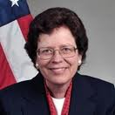 | Regulate trade
Secretary of Labor | Hilda Solis | 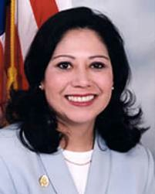 | Jobs
Secretary Health and Human Services | Kathleen Sebelius | 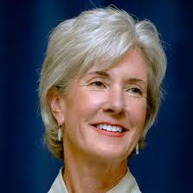 | Hospitals and SSS
Secretary of Housing and Urban Development | Shaun Donovan | 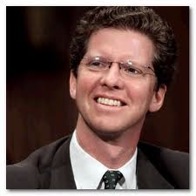 | Housing marketing
Secretary of Transportation | Ray LaHood | 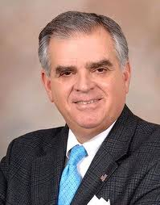 | Busses, trains, cars
Secretary of Energy | Steven Chu | 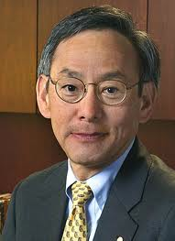 | Natural resources
Secretary of Education | Arne Duncan | 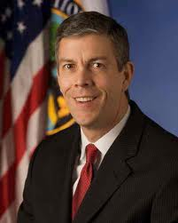 | Education and curriculum
Secretary of Veteran Affairs | Eric Shinseki | 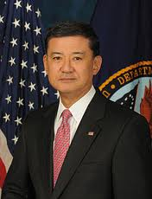 | Help veterans
Secretary of Homeland Security | Janet Napolitano | 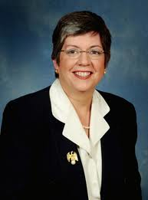 | Terrorists, protect borders

